Simplified, Modernized Meetings Coming Your Way!
Meetings are about to get a whole lot easier.
Your meeting experience is about to get a massive boost! Over the next few weeks you will be hearing more about the transition to BlueJeans meetings.
With HD Video, Dolby Audio, simple intuitive functionality and all the screen sharing features you’ve come to love it’s no wonder companies like Facebook are using BlueJeans to modernize their workforce! (Read their story)
And soon, you will too!
To learn more and get a sneak peek at what’s in store for you please visit BlueJeans.com.

Are You Ready?
BlueJeans meetings are not only simple to use but they are packed with powerful features too!
Did you know that BlueJeans allows you to host your meetings anywhere and anytime? Imagine this, you’re in a noisy coffee shop trying to take that important meeting while grabbing a cup of joe. Dolby noise cancellation ensures your audience hears you loud and clear and not those coffee beans grinding in the background.
But don’t just take our word for it, watch the Hair Dryer Test Video.
And with Launch just a short time away now would be a good time to bookmark our Support Page where you will find a wealth of resources ranging from FAQ’s, Videos, Live Training and More!!

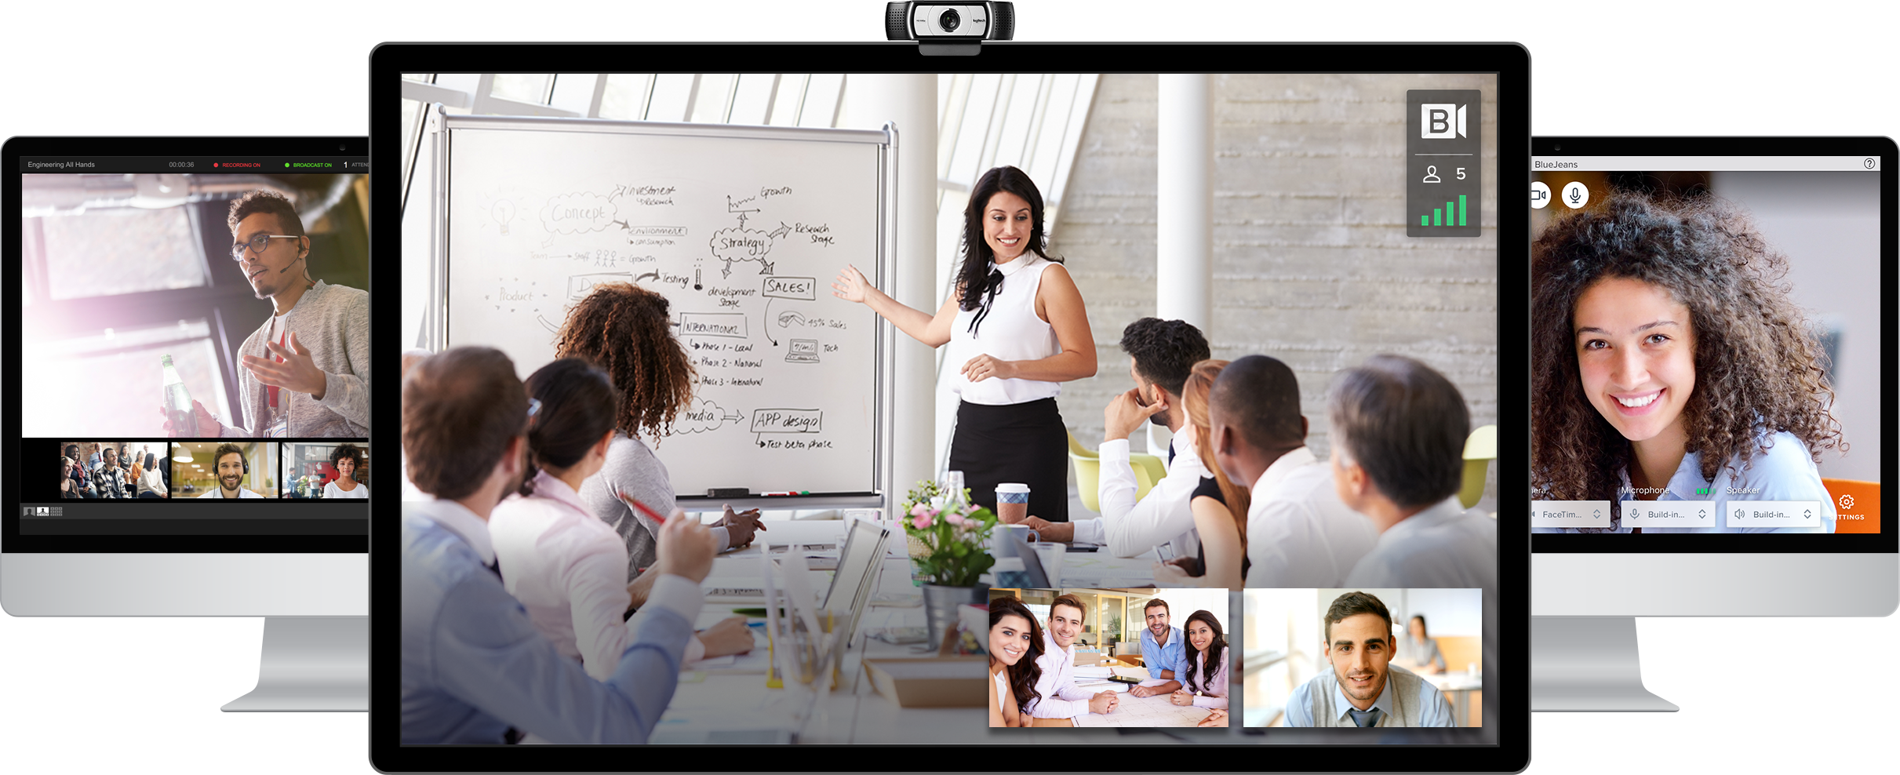

Liftoff!
Experience your NEW platform for modern work NOW!

With the official launch of BlueJeans within your organization you now have access to unparalleled meeting experiences.

Productive meetings involve collaboration on several levels. BlueJeans brings together features like screen sharing, polling, Q&A, recording and text chat to make collaboration easy.

All that’s missing is YOU!

Check out this short video we have prepared for you regarding some Best Practices to get the most out of your meetings.

