Recommended Subjects:
BlueJeans is Upgrading its Desktop App on [DATE] (or)
BlueJeans Made Even Easier with a New Desktop Experience

Hello Team,

On [ENTER DATE HERE], when you launch your BlueJeans desktop app, you will be prompted to update to the new BlueJeans Desktop App 2.0.

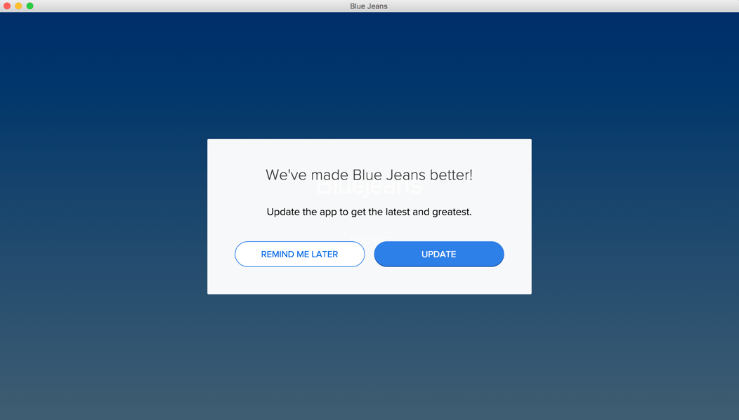

We recommend updating right away to enjoy a new and improved meeting experience that’s faster, simpler, and more delightful - allowing you to join meetings quicker and giving you intuitive meeting controls.

Learn more about the new BlueJeans Desktop App 2.0.

Questions?
If you have any questions or issues, please contact BlueJeans Support.

Cheers,
[Your Name]

